LAB 4: Hlookup Lab

Assume you have the following dataset in an Excel worksheet starting from cell A1:

Worksheet: Sales Data

|  |  |  |  |  |  |
| --- | --- | --- | --- | --- | --- |
| **Product** | **Jan** | **Feb** | **Mar** | **Apr** | **May** |
| Product A | 120 | 130 | 140 | 150 | 160 |
| Product B | 150 | 160 | 170 | 180 | 190 |
| Product C | 200 | 210 | 220 | 230 | 240 |
| Product D | 90 | 100 | 110 | 120 | 130 |
| Product E | 220 | 230 | 240 | 250 | 260 |
| Product F | 130 | 140 | 150 | 160 | 170 |

1. Use HLOOKUP to find the sales for Product A in March.

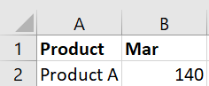

2. Use HLOOKUP to find the sales for Product D in May.

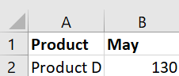

3. Use HLOOKUP to find the sales for Product C in February.

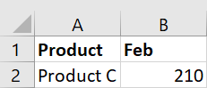

4. Use HLOOKUP to find the sales for each month for a product, then calculate the total sales for that product.

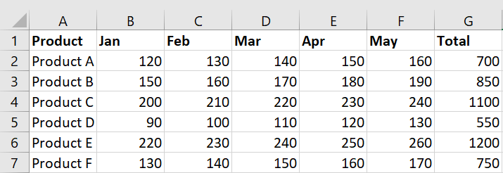

5. Use HLOOKUP to find the maximum sales value for Product B across all months.

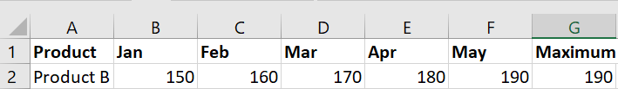

6. Use HLOOKUP to find the minimum sales value for Product F across all months.

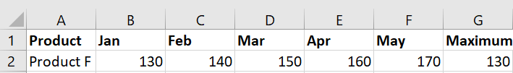

7. Use HLOOKUP to find the average sales value for Product E across all months.

